DBMS LAB QUERIES

EXPERIMENT 10

SUBMITTED BY : ARYA SASI

MCA A BATCH

ROLL NO: 25

1. Create a view view1 from salesorder with (order number,order date)

CREATE VIEW VIEW1 AS SELECT ORDER_NO,ORDER_DATE FROM SALESORDER;

2. Describe the view view1

DESC VIEW1;

3. Display Values of view1

SELECT* FROM VIEW1;

4. Insert one row of data in view1 and observe the output/error message

INSERT INTO VIEW1 VALUES ('5','2013-06-01');

5. Create a view view2 from clientmaster (clientno,cname)

CREATE VIEW VIEW2 AS SELECT CLIENT_NO,CNAME FROM CLIENT_MASTER;

6. Insert one row of data in view2 and observe the output/error message

INSERT INTO VIEW2 VALUES(106,'AMMU');

7. Create a view view3 from salesmaster with all columns with condition ‘city=mumbai’

CREATE VIEW VIEW3 AS SELECT * FROM SALESMASTER WHERE CITY='MUMBAI';

8. Create a view view4 from clientmaster and salesmaster with details (cname,city,sname,city)

CREATE VIEW VIEW4 AS SELECT CNAME ,CLIENT_MASTER.CITY ,SNAME,SALESMASTER.SCITY FROM SALESMASTER,CLIENT_MASTER;

9. Describe view4

DESC VIEW4;

10. Insert one row of data in view4 and observe the output/error message

INSERT INTO VIEW4 VALUES ('NANDU' ,'MUMBAI' ,'AMMU ','MUMBAI' );

11. Create a view view5 from view4(cname,sname)

CREATE VIEW VIEW5 AS SELECT CNAME,SNAME FROM VIEW4;

12. Describe view5

DESC VIEW5;

13. Insert one row of data in view5 and observe the output/error message

INSERT INTO VIEW5 VALUES('DENNO','RONAL');

14. Delete the view4 table

DROP VIEW VIEW4;

15. Delete the view5 table

DROP VIEW VIEW5;

16.

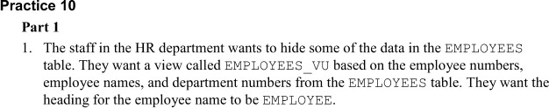 .

CREATE VIEW EMPLOYEES_V AS (SELECT EMPLOYEE_ID,LAST_NAME AS EMPLOYEE,DEPARTMENT_ID FROM EMPLOYEES);

17.

SELECT * FROM EMPLOYEES_V;

18.

SELECT EMPLOYEE,DEPARTMENT_ID FROM EMPLOYEES_VU

VIEW1

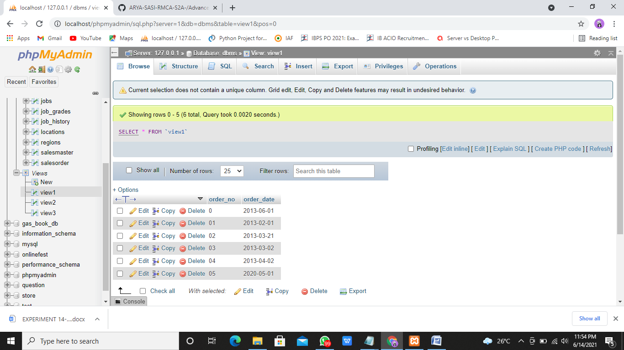

VIEW 2

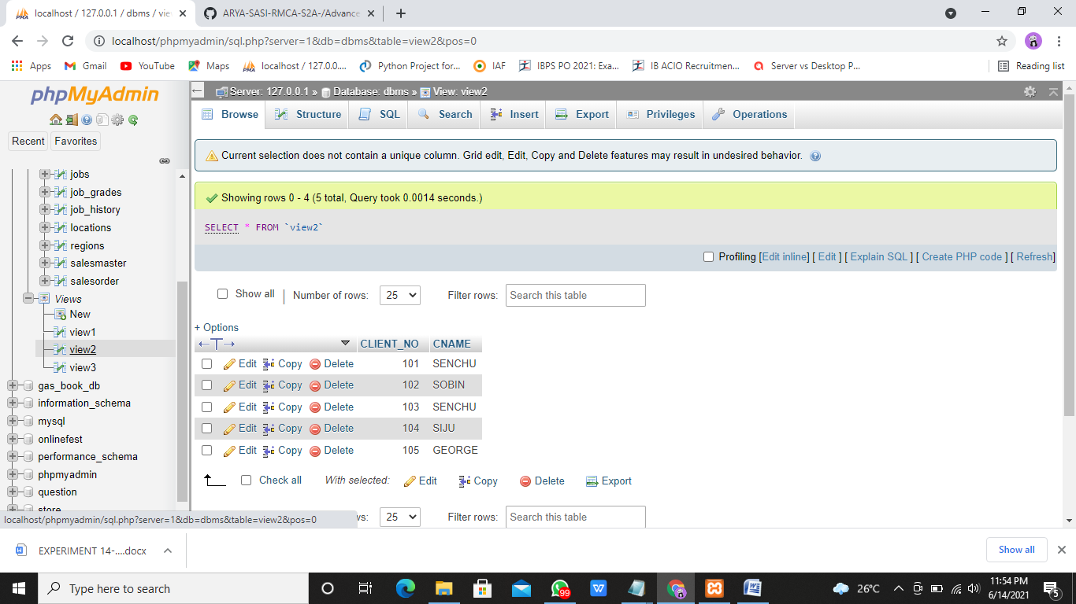

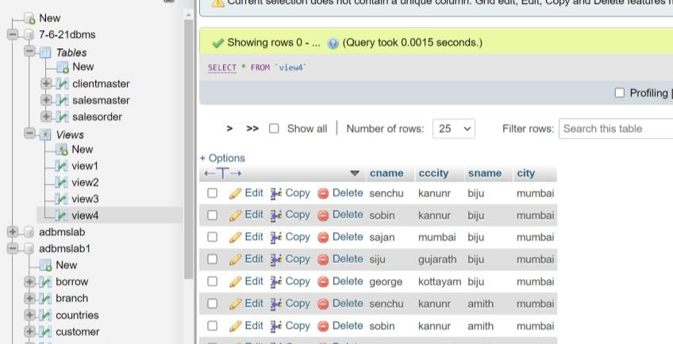 VIEW3

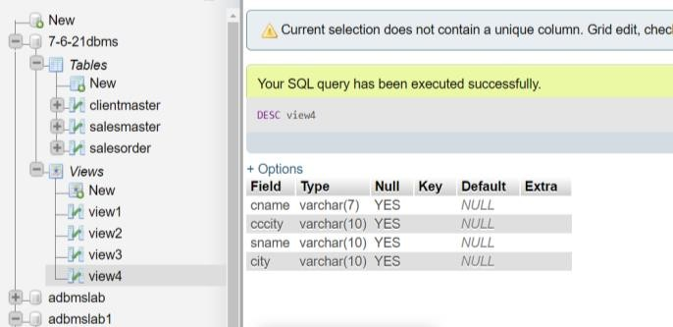 VIEW4

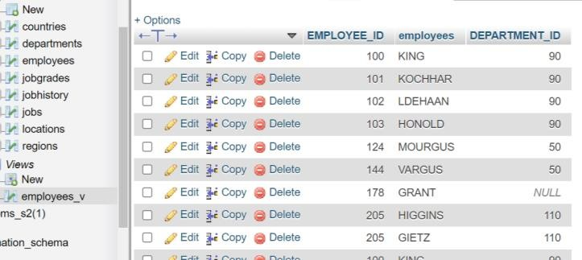 EMPLOYEES_V